

Ninong & Ninang

Genilda C. Lumimbay
Algen R. Banuelos
Andrea Labiran
Ellonor M. Andres
Milagrina O. Tegerero
Marjorie C. Mailed
Geralyn Pelicelda

Roweno Andres
Kert Galinato
Romeo Concon
James Jefferson Dela Cruz
Ronie Cusong
Remlin L. Rojas
Roger Manguiran

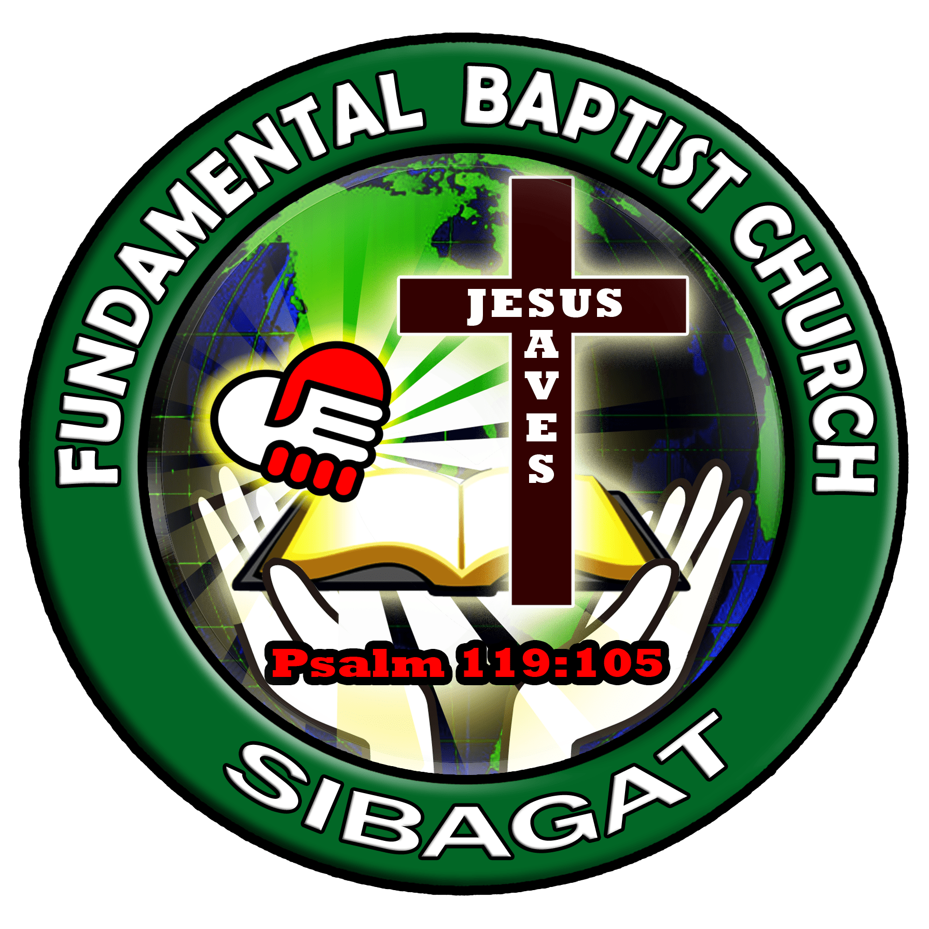
"Children are a heritage from the Lord, offspring a reward from him.".
Psalm 127:3

